**Week 1**

**Tag Description**

Text header, denoted using the <h1>, <h2>, <h3>, <h4> tags.

Paragraph, denoted using the <p> tag.

Horizontal ruler, denoted using the <hr> tag.

An image, denoted using the <img> tag.

HTML Table, <table>. <tr> tag is used for table row.

Table elements <th> are bold and center aligned, <td> are normal and left aligned.

List element with bullets <li>.

**Resume Link**

<https://ap9149.github.io/ResumeAssignment/>

**Screenshot**

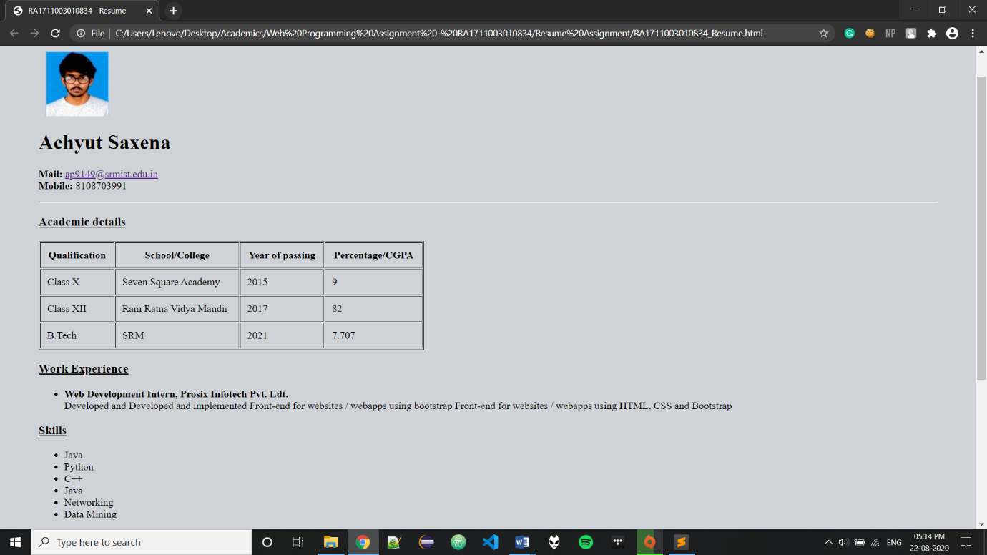

**Source Code**

<head>

<title>RA1711003010834 - Resume</title>

</head>

<style>

th, td {

padding: 10px;

}

</style>

<body style="margin:0; padding:60">

<img src = "photoRA1711003010834.jpg" width = 100 height = 100 hspace = 100 align = right>

<h1> Achyut Saxena</h1>

<p>ap9149@srmist.edu.in<br>

Mobile: 8108703991</p>

<hr noshade>

<h3> <u> ACADEMIC DETAILS </u> </h3>

<table border = 1 width = 1400 >

<tr>

<th> Qualification </th>

<th> School/College </th>

<th> Year of passing </th>

<th> Percentage/CGPA </th>

</tr>

<tr>

<td> Class X </td>

<td> Seven Square Academy </td>

<td> 2015 </td>

<td> 9 </td>

</tr>

<tr>

<td> Class XII </td>

<td> Ram Ratna Vidya Mandir </td>

<td> 2017 </td>

<td> 82 </td>

</tr>

<tr>

<td> B.Tech </td>

<td> SRMIST </td>

<td> 2021 </td>

<td> 7.707 </td>

</tr>

</table>

<h3> <u> INTERNSHIPS </u> </h3>

<p>

<li> Front end Development, Prosix Pvt. Ldt.

</p>

<h3> <u> SKILLS </u> </h3>

<p>

<li> Java

<li> Python

<li> C++

<li> Java

<li> Networking

<li> Data Science

</p>

<h3> <u> PROJECTS</u> </h3>

<p>

<li> Motion Detection

<li> Sudoku Solver

</p>

</body>

</html>